Fast**National University of Computer & Emerging Sciences, Karachi  
Fall/Spring/Summer-2011 CS-Department  
MidTerm 1   
23rd February 2017, 10:30 am – 11:30 am**

|  |  |  |
| --- | --- | --- |
| **Course Code: CS211** | **Course Name: Discrete Structures** | |
| **Instructor Name : Jalaluddin Qureshi** | | |
| **Student Roll No:** | | **Group:** |

Instructions:

* Return the question paper.Read each question completely before answering it. There are **5questions and 1 page.**
* In case of any ambiguity, you may make assumption. But your assumption should not contradict any statement in the question paper.
* Invigilators/ instructor can not assist you in understanding the question.
* All the answers must be solved according to the sequence given in the question paper.
* Marks will be awarded iff justifications has been provided.

**Time**: 60 minutes. **Max Marks**: 10mark/question x 5questions = 50 marks

**Part A (Set Theory)**

Question 1:

Using the following relationship: |AUB|=|A|+|B|- |A∩B| (1),

Show that the following can be derived:

|AUBUC|=|A|+|B|+|C|- |A∩B|- |A∩C|- |C∩B|+|A∩B∩C| (2).

Based on this exercise, and using Equation (1) and/or (2) derive the formula for |A U B U C U D|.

**Solution:**

Use substitution method, let, T=BUC, so we have,

|AUT|=|A|+|T|- |A∩T|

|AUBUC|=|A|+|BUC|- |A∩(BUC)|

Since |BUC|=|B|+|C|- |B∩C|,

|AUBUC|=|A|+|B|+|C|- |B∩C|- |A∩(BUC)|

|AUBUC|=|A|+|B|+|C|- |B∩C|- |(A∩B) U (A∩C)|

|AUBUC|=|A|+|B|+|C|- |B∩C|- (|(A∩B)|+|(A∩C)| - |A∩B∩C |)

|AUBUC|=|A|+|B|+|C|- |A∩B|- |A∩C|- |C∩B|+|A∩B∩C|

The same approach of substitution can be used to show that,

|A U B U C U D|= |A|+|B|+|C| +|D| - |A∩B|- |A∩C|- |C∩B| - |A∩D| - |B∩D| -

|C∩D|+|A∩B∩C|+|A∩B∩D|+|D∩B∩C|+|A∩C∩D| - |A∩B∩C∩D |

Question 2:

If A={2,3,4,g,FAST,star}, B={4,f,yoyo, 2, golf, 2}, C={yoyo, 10, 7, f, 4, FAST},   
U= A U B U C U {3, golf, 7, tent, 0, 11}, (Hint: U is the universal set). Find the following, and plot these on a Venn Diagram (by shading appropriate region).

1. Ac∩B (b) (U \B)∩ Cc
2. (A \U) U (C\B) (d) (A∩C)c \ B

**Solution:**

The solution is given by the elements in the common region.

(a)

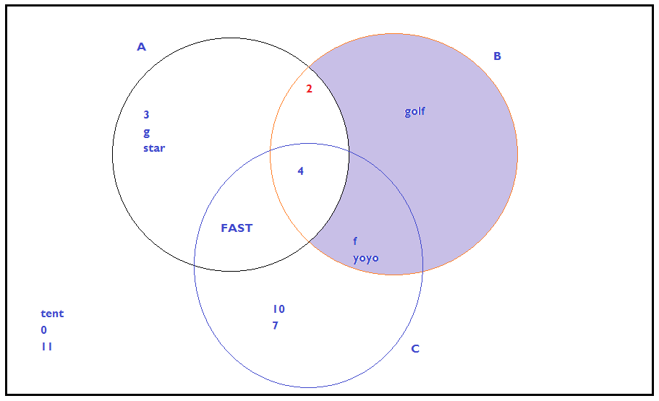

(b)

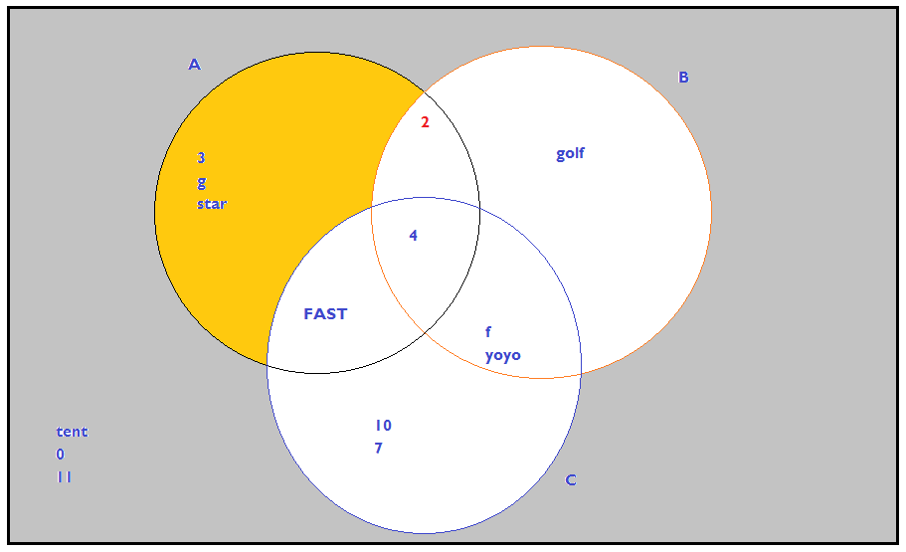

(c)

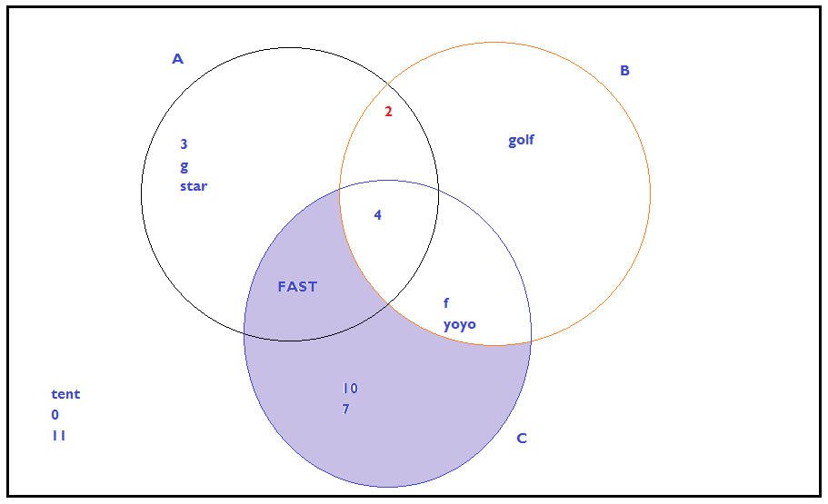

(d)

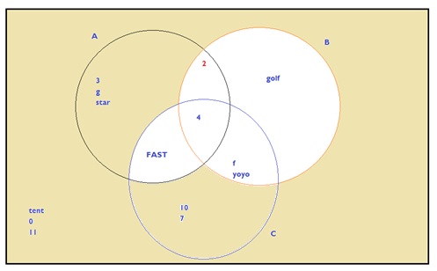

**Part B (Logic Theory)**

Question 3:

Determine (using appropriate technique) whether the following relationship is correct/ incorrect:

P (Q∨R) (PQ)∧(PR).

**Solution:**

|  |  |  |  |  |  |  |  |  |  |
| --- | --- | --- | --- | --- | --- | --- | --- | --- | --- |
|  |  |  |  |  |  |  | M | N |  |
|  | P | ¬P | Q | R | Q∨R | P→ (Q∨R) | (P→Q) | (¬P→R) | M∧N |
| 1 | T | F | T | T | T | T | T | T | T |
| 2 | T | F | T | F | T | T | T | T | T |
| 3 | T | F | F | F | F | F | F | T | F |
| 4 | T | F | F | T | T | T | F | T | F |
| 5 | F | T | T | F | T | T | T | F | F |
| 6 | F | T | F | T | T | T | T | T | T |
| 7 | F | T | F | F | F | T | T | F | F |
| 8 | F | T | T | T | T | T | T | T | T |

As the two truth tables are not same, the equivalence relationship is false.

As there are two tables (with total 16 entries), at the discretion of the examiner, you will lose 1 marks for a wrong entry.

Question 4:

Determine whether the assignment c←c+1 (read as, c is assigned the value given by c plus one) will be executed by the if-statement, where x←5, y←3, z←7.

1. If {(x<y) ∧ (y≤z)} then c←c+1 (b) If {(x=z) ∧ ((x≤z)} then c←c+1

(c) If {(x≥y) ∨ (x<z)} then c←c+1 (d) If {(x≤z) ∨ (y=z)} then c←c+1

**Solution:**

1. {(x<y) ∧ (y≤z)} then c←c+1 TRUE  
   (x<y) is false, (y≤z) is true, their conjunction is false, and negation of this is true.
2. {(x=z) ∧ ((x≤z)} then c←c+1 TRUE  
   (x=z) is false, (x≤z) is true, their conjunction is false, and negation of this is true.
3. {(x≥y) ∨ (x<z)} then c←c+1 FALSE  
   (x≥y) is true, (x<z) is also true, their disjunction is true, and its negation is false.
4. {(x≤z) ∨ (y=z)} then c←c+1 FALSE  
   (x≤z) is true, (y=z) is false, their disjunction is true, and its negation is false.

Question 5:

Using the algebra of Propositions, simplify the following:

(x∨y∨z) ∧ (x∨y∨z) ∨ (w∧x)

After the simplication, draw its truth table.

**Solution**

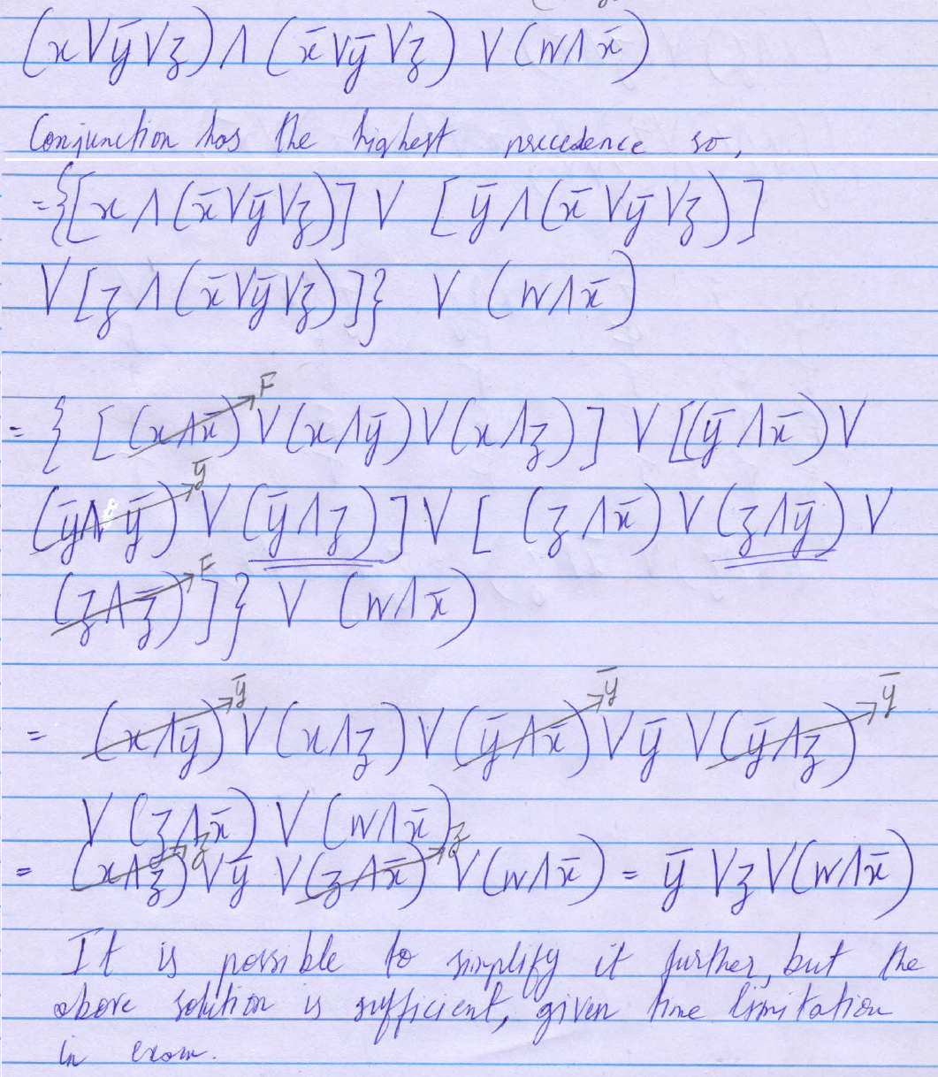

Based on the above reduction, a truth table for the above can be easily drawn.